# Introduction

This project is about performing 2D convolution of three different filters through an image. The three types of convolutions performed were standard 2D convolution through a filter, Sobel filter for edge detection, and correlation.

# 2D Convolution

The filter used for this convolution is a 5x5 filter h.

$h=1/81\left[\begin{matrix}1 & 2 & 3 & 2 & 1 \\ 2 & 4 & 6 & 4 & 2 \\ 3 & 6 & 9 & 6 & 3 \\ 2 & 4 & 6 & 4 & 2 \\ 1 & 2 & 3 & 2 & 1\end{matrix}\right]$

Equation

The original image is a black and white image of a man in front of a bookcase [Figure 1]. This image is convolved with the filter h [Equation 1]. The resulting image [Figure 2] is a slightly blurry version of the original image. This filter takes the original pixel, and adds its value to other surrounding with certain weights. The original pixel has the greatest weight with the weight decreasing as you go out into the surrounding 5x5 pixels.

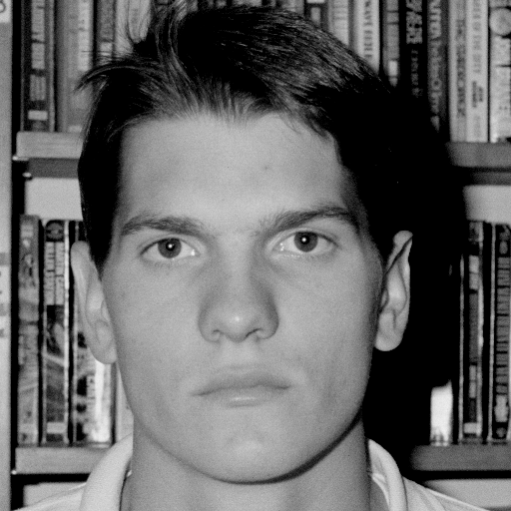

Figure Original Image

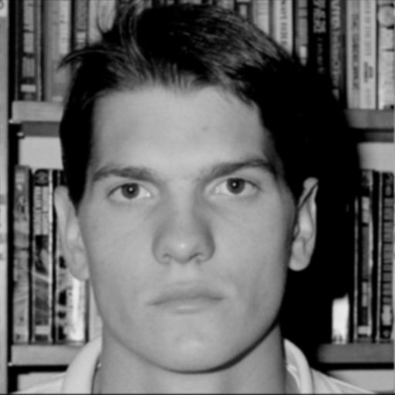

Figure Fuzzy Image

# Sobel Filter

The sobel filter is two filters S1 and S2 [Equation 2] convolved with the input image [Figure 1] and added together to create the output image [Figure 3]. These filters cause edge detection in the output image where white is where there is a contrast between neighboring pixels.

$$S1=\left[\begin{matrix}1 & 0 & -1 \\ 2 & 0 & -2 \\ 1 & 0 & -1\end{matrix}\right] S2= \left[\begin{matrix}-1 & -2 & -1 \\ 0 & 0 & 0 \\ 1 & 2 & 1\end{matrix}\right]$$

Equation

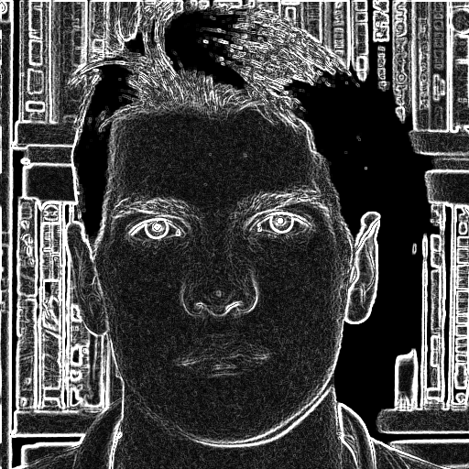

Figure Edge Detection

# Correlation

Correlation takes a small image [Figure 4] and compares it with the input image [Figure 1]. The output image [Figure 5] shows white where the two images are similar and black where they are different. First, the pixel values in the original image are squared and convolved with a filter of the same size as the input filter with all h[m,n]=1. The original input image is convolved with the original filter, and the individual pixels in the resulting image are divided by the pixel values in the previous image. The resulting pixels are then scaled to be between 0-255.

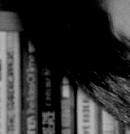

Figure Filter Image

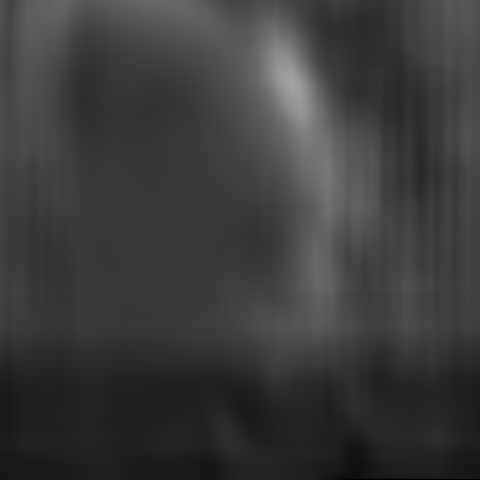

Figure Correlation Image

# Conclusion

As we did a similar project in Discrete Signals, I was able use some of my old code. I updated most of the code to use a class structure and made general improvements to the code to make it more general for any .pgm file and filter. I did encounter some issues where after allocating memory and reading in the input file. I tried to return the pointer holding that data from a GetData() function, but after returning, I think garbage collection deallocated my array holding the data. I just learned I had to allocate in the caller function and then everything worked. I do think it is amazing how a simple matrix can modify an image like in the sobel filter to create edge filtering.

# Code Appendix

## main.cpp

#include "Convolution.h"

#include "pgmIO.h"

/**

* **\brief** Multiplies the given matrix with a scalar

* **\param** scalar

* **\param** h matrix to multiply

* **\param** m number of rows in matrix

* **\param** n number of column in matrix

*/

void MultMatrixScalar**(**const double scalar**,** double **\***h**,** const int m**,** const int n**)**

**{**

**for(**auto i**=**0**;** i**<**m**;** i**++)**

**{**

**for(**auto j**=**0**;** j**<**n**;** j**++)**

**{**

h**[**i**\***m**+**j**]** **=** scalar **\*** h**[**i**\***m**+**j**];**

**}**

**}**

**}**

int main**(**const int argc**,** char **\***argv**[])**

**{**

**if** **(**argc **<** 3**)**

**{**

printf**(**"Wrong number of arguments"**);**

printf**(**"Format: .exe inFile outFile"**);**

exit**(**EXIT_FAILURE**);**

**}**

double h**[]** **=** **{**

1**,**2**,**3**,**2**,**1**,**

2**,**4**,**6**,**4**,**2**,**

3**,**6**,**9**,**6**,**3**,**

2**,**4**,**6**,**4**,**2**,**

1**,**2**,**3**,**2**,**1

**};**

MultMatrixScalar**(**1 **/** 81.0f**,** h**,** 5**,** 5**);**

//Convolution::Conv2D(argv[1], argv[2], h, 5, 5);

//Convolution::Sobel(argv[1], argv[2]);

Convolution**::**Correlate**(**argv**[**1**],** argv**[**2**],** argv**[**3**]);**

**return** 0**;**

**}**

## PgmIO.h

#pragma once

#include <cstdio>

#include <string>

#include <fstream>

#include <sstream>

#pragma warning(disable:4996)

**using** **namespace** std**;**

// ReSharper disable CppInconsistentNaming

class PgmIO

// ReSharper restore CppInconsistentNaming

**{**

public**:**

/**

* **\brief** Attempts to open the given .pgm files and parses the header.

* **\param** inFile Input .pgm

* **\param** outFile Output .pgm

*/

PgmIO**(**const string**&** inFile**,** const string**&** outFile **=** "noFile"**)**

**{**

in**.**open**(**inFile**,** ios**::**in **|** ios**::**binary**);**

**if(**outFile **!=** "noFile"**)**out**.**open**(**outFile**,** ios**::**binary **|** ios**::**out**);**

**if** **(!**in**.**is_open**())**

**{**

printf**(**"Error opening input file\n"**);**

exit**(**EXIT_FAILURE**);**

**}**

**if** **(**outFile **!=** "noFile" **&&** **!**out**.**is_open**())**

**{**

printf**(**"error opening output file\n"**);**

exit**(**EXIT_FAILURE**);**

**}**

HeaderParser**();**

**}**

**~**PgmIO**()**

**{**

in**.**close**();**

out**.**close**();**

**}**

**typedef** struct

**{**

//2 char number to identify file type, pgm is P5

string magicNumber**;**

//comments starting each line with #

string comments**;**

// width of the image

int width**{};**

//height of the image

int height**{};**

//max gray value

int maxVal**{};**

**}** pgm_file_header**;**

/**

* **\brief** Parse the data of the input file into a vector. Must allocate space for x before hand

* **\param** x vector to store data into.

* **\param** xOffSet offset for where to read data into x

* **\param** yOffSet offset for where to read data into y

*/

void GetData**(**double **\*** x**,** const int xOffSet **=** 0**,** const int yOffSet **=** 0**)**

**{**

string ss**;**

const auto temp **=** **new** unsigned char**[**dataSize**];**

in**.**seekg**(**dataIndex**,** ios**::**beg**);**

in**.**read**(reinterpret_cast<**char**\*>(**temp**),** dataSize**);**

//put image into padded x

**for** **(**auto i **=** 0**;** i **<** header**.**height**;** i**++)**

**{**

**for** **(**auto j **=** 0**;** j **<** header**.**width**;** j**++)**

**{**

x**[(**i**+**xOffSet**)\***header**.**width **+** yOffSet**+**j**]** **=** temp**[**i**\***header**.**width**+**j**];**

**}**

**}**

**delete[]** temp**;**

**}**

/**

* **\brief** Gets the header of the input file

* **\return** header

*/

pgm_file_header GetHeader**()** const

**{**

**return** header**;**

**}**

/**

* **\brief** Writes data to output file .pgm

* **\param** y Data vector to output

* **\param** yHeader Header to use for .pgm

* **\param** mOffset y row offset due to H

* **\param** nOffset y col offset due to H

*/

void WriteData**(**double **\***y**,** const pgm_file_header yHeader**,** const int mOffset **=** 0**,** const int nOffset **=** 0**)**

**{**

string dim**;**

dim**.**assign**(**header**.**magicNumber**).**append**(**"\n"**).**append**(**header**.**comments**).**append**(**"\n"**);**

out**.**write**(**dim**.**c_str**(),** dim**.**length**());**

dim**.**assign**(**std**::**to_string**(**header**.**width**)).**append**(**" "**).**append**(**std**::**to_string**(**header**.**height**)).**append**(**"\n"**);**

out**.**write**(**dim**.**c_str**(),** dim**.**length**());**

dim**.**assign**(**std**::**to_string**(**header**.**maxVal**)).**append**(**"\n"**);**

out**.**write**(**dim**.**c_str**(),** dim**.**length**());**

**for** **(**auto i **=** 0**;** i **<** yHeader**.**width**\***yHeader**.**height**;** i**++)**

**{**

**if** **(**y**[**i**]** **<** 0**)** y**[**i**]** **=** 0**;**

**if** **(**y**[**i**]** **>** header**.**maxVal**)** y**[**i**]** **=** header**.**maxVal**;**

**}**

auto**\*** temp **=** **new** unsigned char**[**dataSize**];**

**for** **(**auto i **=** 0**;** i **<** header**.**height**;** i**++)**

**{**

**for(**auto j**=**0**;** j **<** header**.**width**;** j**++)**

**{**

temp**[**i**\***header**.**width**+**j**]** **=** **static_cast<**int**>(**floor**(**y**[(**i**+**mOffset**)\***yHeader**.**width**+**j**+**nOffset**]));**

**}**

**}**

out**.**write**(reinterpret_cast<**char**\*>(**temp**),** dataSize**);**

out**.**close**();**

**delete[]** temp**;**

**}**

int dataSize**{};**

private**:**

ifstream in**;**

ofstream out**;**

pgm_file_header header**;**

int dataIndex**{};**

/**

* **\brief** Parse the .pgm header and stores the data into the header var

*/

void HeaderParser**()**

**{**

auto buffer **=** ReadLine**();**

**if** **(**buffer **!=** "P5"**)**

**{**

printf**(**"Invalid file format"**);**

exit**(**EXIT_FAILURE**);**

**}**

header**.**magicNumber **=** buffer**;**

**do**

**{**

buffer **=** ReadLine**();**

**if** **(!**buffer**.**find**(**'#'**))** header**.**comments**.**append**(**buffer**).**append**(**"\n"**);**

**}** **while** **(!**buffer**.**find**(**'#'**));**

auto size **=** 0**;**

header**.**width **=** stoi**(**Split**(**buffer**,** size**)[**0**]);**

**if(**size**>**1**)** header**.**height **=** stoi**(**Split**(**buffer**,** size**)[**1**]);**

**else**

**{**

header**.**height **=** stoi**(**ReadLine**());**

**}**

header**.**maxVal **=** stoi**(**ReadLine**());**

dataIndex **=** in**.**tellg**();**

dataSize **=** header**.**width**\***header**.**height**;**

**}**

/**

* **\brief** Split the given string into an array of strings

* **\param** str string to parse

* **\param** size size of the output array

* **\param** delim delimiter to separate strings

* **\return** array of strings. max size 10.

*/

string**\*** Split**(**const std**::**string**&** str**,** int **&**size**,** const char delim **=** ' '**)** const

**{**

auto**\*** cString **=** **new** string**[**10**];**

stringstream ss**(**str**);**

string token**;**

auto i **=** 0**;**

size **=** 0**;**

**while** **(**getline**(**ss**,** token**,** delim**))**

**{**

cString**[**i**++]** **=** token**;**

size**++;**

**}**

**return** cString**;**

**}**

/**

* **\brief** Read in n bytes (unsigned char)

* **\param** numBytes number of bytes to read in, default 1

* **\return** c string with the given byte. Terminated in NULL

*/

char**\*** ReadByte**(**const int numBytes **=** 1**)**

**{**

const auto buffer **=** **new** char**[**numBytes **+** 1**];**

in**.**read**(**buffer**,** numBytes**);**

//string retVal(buffer, numBytes);

buffer**[**numBytes**]** **=** **NULL;**

**return** buffer**;**

**}**

/**

* **\brief** Read in the line up until the delimiter

* **\param** delim delimiter for when to stop looking. Default new line

* **\return** The parsed line NOT including the delimiter

*/

string ReadLine**(**const char delim **=** '\n'**)**

**{**

string retVal**,** buffer**;**

**do**

**{**

retVal**.**append**(**buffer**);**

buffer**.**assign**(**ReadByte**());**

**}** **while** **(**buffer**.**find**(**delim**));**

**return** retVal**;**

**}**

/**

* **\brief** Normalizes the upper and lower limits of the signal.

* Anything lower than 0 becomes 0.

* Anything higher than the header maxVal becomes maxVal

* **\param** p Data to normalize

*/

void NormalizeBounds**(**double**\*** p**)** const

**{**

**for** **(**auto i **=** 0**;** i **<** dataSize**;** i**++)**

**{**

**if** **(**p**[**i**]** **<** 0**)** p**[**i**]** **=** 0**;**

**if** **(**p**[**i**]** **>** header**.**maxVal**)** p**[**i**]** **=** header**.**maxVal**;**

**}**

**}**

**};**

## Convolution.h

#pragma once

#include <string>

#include "pgmIO.h"

#include "Convolution.h"

#include <algorithm>

#include <iostream>

**using** **namespace** std**;**

class Convolution

**{**

public**:**

Convolution**()** **=** **default;**

/**

* **\brief** 2D Convolve the given signal with a given h matrix. Writes out the result to a file

* **\param** inFile Input .pgm file

* **\param** outFile Output .pgm file

* **\param** h h matrix set up as a vector (h[x*numCol+y])

* **\param** hM number of rows in h

* **\param** hN number of columns in h

*/

static void Conv2D**(**char**\*** inFile**,** char**\*** outFile**,** double**\*** h**,** const int hM**,** const int hN**)**

**{**

PgmIO pgmFile**(**inFile**,** outFile**);**

// ReSharper disable CppInconsistentNaming

const auto rowX **=** pgmFile**.**GetHeader**().**height**,**

colX **=** pgmFile**.**GetHeader**().**width**,**

rowZ **=** rowX **+** 2 **\*** **(**hM **-** 1**),**

colZ **=** colX **+** 2 **\*** **(**hN **-** 1**),**

rowY **=** rowX **+** hM **-** 1**,**

colY **=** colX **+** hN **-** 1**;**

// ReSharper restore CppInconsistentNaming

//Allocate and get data

const auto y **=** **static_cast<**double**\*>(**calloc**(sizeof(**double**),** rowY **\*** colY**));**

const auto x **=** **static_cast<**double**\*>(**calloc**(sizeof(**double**),** rowZ **\*** colZ**));**

pgmFile**.**GetData**(**x**,** hM **-** 1**,** hN **-** 1**);**

Convolve2D**(**y**,** rowY**,** colY**,** x**,** rowX**,** colX**,** h**,** hM**,** hN**);**

auto yHeader **=** pgmFile**.**GetHeader**();**

yHeader**.**width **=** colY**;**

yHeader**.**height **=** rowY**;**

//Output to file and cleanup

pgmFile**.**WriteData**(**y**,** yHeader**,** hM **-** 2**,** hN **-** 2**);**

free**(**y**);**

free**(**x**);**

**}**

/**

* **\brief** 2D Convolve the given signal with two matrices S1 and S2. The output is

* edge detection of the given image. Writes out the result to a file

* **\param** inFile Input .pgm file

* **\param** outFile Output .pgm file

*/

static void Sobel**(**char**\*** inFile**,** char**\*** outFile**)**

**{**

#define X(u,v) x[(u)*colX+(v)]

#define S1(u,v) s1[(u)*colH+(v)]

#define S2(u,v) s2[(u)*colH+(v)]

#define Y(u,v) y[(u)*colY+(v)]

PgmIO pgmFile**(**inFile**,** outFile**);**

// ReSharper disable CppInconsistentNaming

const auto rowX **=** pgmFile**.**GetHeader**().**height**,**

colX **=** pgmFile**.**GetHeader**().**width**,**

rowH **=** 3**,**

colH **=** 3**,**

rowY **=** rowX **+(**rowH **-** 1**),**

colY **=** colX **+**colH **-** 1**,**

rowZ **=** rowX **+** 2 **\*** **(**rowH **-** 1**),**

colZ **=** colX **+** 2 **\*** **(**colH **-** 1**);**

// ReSharper restore CppInconsistentNaming

//Allocate and get data for x

const auto y **=** **static_cast<**double**\*>(**calloc**(sizeof(**double**),** rowY **\*** colY**));**

const auto x **=** **static_cast<**double**\*>(**calloc**(sizeof(**double**),** rowZ **\*** colZ**));**

//zero pad the bounds of x

pgmFile**.**GetData**(**x**,** rowH **-** 1**,** colH **-** 1**);**

double s1**[]** **=** **{**

1**,** 0**,** **-**1**,**

2**,** 0**,** **-**2**,**

1**,** 0**,** **-**1

**};**

double s2**[]** **=** **{**

**-**1**,** **-**2**,** **-**1**,**

0**,** 0**,** 0**,**

1**,** 2**,** 1

**};**

//convolve with S1 S2 and combine the result

auto tempX **=** 0.0f**,** tempY **=** 0.0f**;**

**for** **(**auto k **=** 0**;** k **<** rowY**;** k**++)**

**{**

//Y-row

**for** **(**auto l **=** 0**;** l **<** colY**;** l**++)**

**{**

//Y-col

**for** **(**auto i **=** 0**;** i **<** rowH**;** i**++)**

**{**

//H-row

**for** **(**auto j **=** 0**;** j **<** colH**;** j**++)**

**{**

//H-col

//-(i-k) = k+i

tempX **+=** S1**(**i**,** j**)** **\*** X**(**k **+** i**,** l **+** j**);**

tempY **+=** S2**(**i**,** j**)** **\*** X**(**k **+** i**,** l **+** j**);**

**}**

**}**

const auto res **=** **static_cast<**int**>(**abs**(**tempX**)** **+** abs**(**tempY**));**

Y**(**k**,** l**)** **=** res**;**

tempX **=** 0.0f**,** tempY **=** 0.0f**;**

**}**

**}**

//write data out to file and cleanup

pgmFile**.**WriteData**(**y**,** pgmFile**.**GetHeader**());**

free**(**y**);**

free**(**x**);**

**}**

static void Correlate**(**char**\*** inFile**,** char**\*** outFile**,** char**\*** hFile**)**

**{**

PgmIO xPgm**(**inFile**,** outFile**);**

PgmIO hPgm**(**hFile**);**

auto yHeader **=** xPgm**.**GetHeader**();**

const auto rowX **=** xPgm**.**GetHeader**().**height**,**

colX **=** xPgm**.**GetHeader**().**width**,**

rowH **=** hPgm**.**GetHeader**().**height**,**

colH **=** hPgm**.**GetHeader**().**width**,**

rowZ **=** rowX **+** 2 **\*** **(**rowH **-** 1**),**

colZ **=** colX **+** 2 **\*** **(**colH **-** 1**),**

rowY **=** rowX **+** **(**rowH **-** 1**),**

colY **=** colX **+** **(**colH **-** 1**);**

yHeader**.**width **=** colY**;**

yHeader**.**height **=** rowY**;**

const auto x **=** **static_cast<**double**\*>(**calloc**(sizeof(**double**),** rowZ **\*** colZ**));**

const auto h **=** **static_cast<**double**\*>(**calloc**(sizeof(**double**),** rowH **\*** colH**));**

const auto x2 **=** **static_cast<**double**\*>(**calloc**(sizeof(**double**),** rowZ **\*** colZ**));**

const auto h2 **=** **static_cast<**double**\*>(**calloc**(sizeof(**double**),** rowH **\*** colH**));**

const auto y1 **=** **static_cast<**double**\*>(**calloc**(sizeof(**double**),** rowY **\*** colY**));**

const auto y2 **=** **static_cast<**double**\*>(**calloc**(sizeof(**double**),** rowY **\*** colY**));**

xPgm**.**GetData**(**x**,** rowH **-** 1**,** colH **-** 1**);**

hPgm**.**GetData**(**h**);**

**for** **(**auto i **=** 0**;** i **<** rowZ **\*** colZ**;** i**++)**

**{**

x2**[**i**]** **=** pow**(**x**[**i**],** 2**);**

**}**

**for** **(**auto i **=** 0**;** i **<** rowH **\*** colH**;** i**++)**

**{**

h2**[**i**]** **=** 1**;**

**}**

Convolve2D**(**y2**,** rowY**,** colY**,** x2**,** rowX**,** colX**,** h2**,** rowH**,** colH**);**

Convolve2D**(**y1**,** rowY**,** colY**,** x**,** rowX**,** colX**,** h**,** rowH**,** colH**);**

**for** **(**auto i **=** 0**;** i **<** rowY **\*** colY**;** i**++)**

**{**

y1**[**i**]** **/=** y2**[**i**];**

**}**

ScaleValues**(**y1**,** rowY **\*** colY**,** 255**);**

xPgm**.**WriteData**(**y1**,** yHeader**,** hPgm**.**GetHeader**().**height **-** 1**,** hPgm**.**GetHeader**().**width **-** 1**);**

free**(**x**);**

free**(**h**);**

free**(**x2**);**

free**(**h2**);**

free**(**y1**);**

free**(**y2**);**

**}**

private**:**

static void Convolve2D**(**double**\*** y**,** const int yM**,** const int yN**,** const double**\*** x**,** const int xM**,** const int xN**,**

const double**\*** h**,** const int hM**,** const int hN**)**

**{**

#define Y(u,v) y[(u)*yN+(v)]

#define X(u,v) x[(u)*xN+(v)]

#define H(u,v) h[(u)*hN+(v)]

//Convolve

auto result **=** 0.0f**;**

**for** **(**auto k **=** 0**;** k **<** yM**;** k**++)**

**{**

//Y-row

**for** **(**auto l **=** 0**;** l **<** yN**;** l**++)**

**{**

//Y-col

**for** **(**auto i **=** 0**;** i **<** hM**;** i**++)**

**{**

//H-row

**for** **(**auto j **=** 0**;** j **<** hN**;** j**++)**

**{**

//H-col

result **+=** H**(**i**,** j**)** **\*** X**(**k **+** i**,** l **+** j**);**

**}**

**}**

Y**(**k**,** l**)** **=** result**;**

result **=** 0.0f**;**

**}**

**}**

**}**

static void ScaleValues**(**double**\*** y**,** const int n**,** const double maxOut**)**

**{**

const auto maxVal **=** **\***max_element**(**y**,** y **+** n**);**

**for** **(**auto i **=** 0**;** i **<** n**;** i**++)**

**{**

y**[**i**]** **=** y**[**i**]** **/** maxVal **\*** maxOut**;**

**}**

**}**

**};**